

Industry GRADE PROJECT 3

Customer Retention Strategy



Edureka

Edureka

**Business Challenge/Requirement**

Customer retention and acquisition strategies are on top of every organization’s agenda.

To offer better customer service and boost loyalty, a company has to invest in a state-of-the-art CRM tool.

In pursuit of these goals, every organization implements CRM as a strategy that integrates the concepts of data mining and data warehousing. The data collected through the CRM helps the leadership team make actionable decisions in real time.

It helps them build and retain long-term and profitable relationships with customers. FutureCart Inc. is a hypothetical leading retail company with an omnipresence in India with more than 5000 retail stores and hypermarkets across and e-commerce in the country. The company has formed a dedicated team to handle after-sales services. The team is entrusted with the responsibility to address customer complaints and delight them - and eventually increase brand loyalty

**Abstract**

The company has multiple contact centers across India to provide support service to their customers

• Customers can reach out to the care team over different communication channels depending on their preference and convenience: Calls, Chat, or Email. • CCR (Customer Care Representative) registers the complaint by collecting all the necessary details - - which is called a case

• A case can have a status -- open or closed

• Each case can belong to a category and sub-category. This category and sub-category will determine case priority. Depending on the priority key, CCR has an SLA (in hours) to close the case within the SLA hours

• Once a case is closed, the customer is sent a survey link to rate the overall experience of interacting with the contact center representative

• The customer can take a survey or leave it unattended. The customer can rate the experience on a scale of 1-10 on various questions

• Survey response is captured for that particular case

**Data-Flow Architecture Diagram**

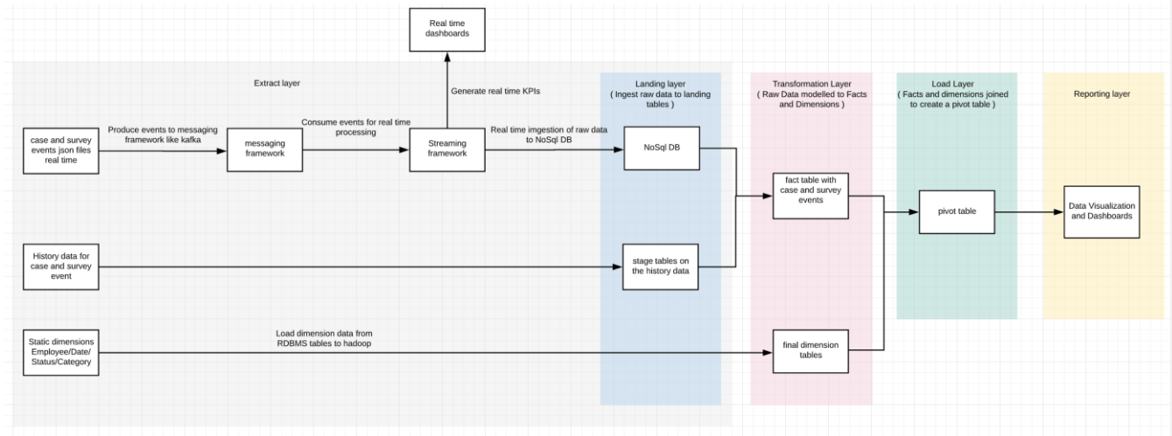

**Details of the fact and dimension tables :**

Hive DB - edureka_918210_DB_Industry_projects_futurecart

Fact Tables :

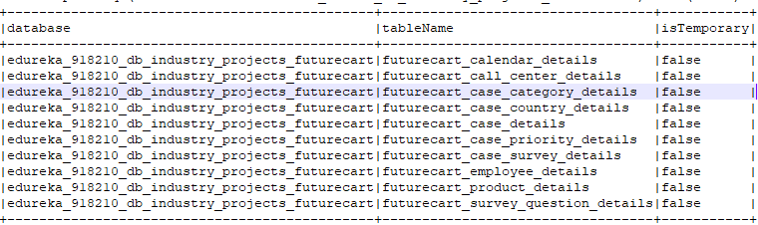

**Customer Retention Strategy**

[edureka_918210@ip-20-0-41-164 batchdata]$ hadoop fs -ls /user/edureka_918210/project_futurecart/batchdata

Found 10 items

-rw-r--r-- 3 edureka_918210 hadoop 1822863 2021-01-14 14:07 /user/edureka_918210/project_futurecart/batchdata/futurecart_calendar_details.txt

-rw-r--r-- 3 edureka_918210 hadoop 864 2021-01-14 14:07 /user/edureka_918210/project_futurecart/batchdata/futurecart_call_center_details.txt

-rw-r--r-- 3 edureka_918210 hadoop 965 2021-01-14 14:07 /user/edureka_918210/project_futurecart/batchdata/futurecart_case_category_details.txt

-rw-r--r-- 3 edureka_918210 hadoop 4231 2021-01-14 14:07 /user/edureka_918210/project_futurecart/batchdata/futurecart_case_country_details.txt

-rw-r--r-- 3 edureka_918210 hadoop 75311462 2021-01-14 14:07 /user/edureka_918210/project_futurecart/batchdata/futurecart_case_details.txt

-rw-r--r-- 3 edureka_918210 hadoop 523 2021-01-14 14:07 /user/edureka_918210/project_futurecart/batchdata/futurecart_case_priority_details.txt

-rw-r--r-- 3 edureka_918210 hadoop 18320270 2021-01-14 14:07 /user/edureka_918210/project_futurecart/batchdata/futurecart_case_survey_details.txt

-rw-r--r-- 3 edureka_918210 hadoop 24342084 2021-01-14 14:07 /user/edureka_918210/project_futurecart/batchdata/futurecart_employee_details.txt

-rw-r--r-- 3 edureka_918210 hadoop 5564844 2021-01-14 14:07 /user/edureka_918210/project_futurecart/batchdata/futurecart_product_details.txt

-rw-r--r-- 3 edureka_918210 hadoop 597 2021-01-14 14:07 /user/edureka_918210/project_futurecart/batchdata/futurecart_survey_question_details.txt

[edureka_918210@ip-20-0-41-164 batchdata]$

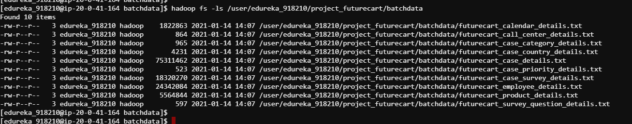

[edureka_918210@ip-20-0-41-62 project_retailcart]$ hadoop fs -ls /bigdatapgp/common_folder/project_retailcart/realtimedata

Found 2 items

-rw-r--r-- 3 evaluationuser01 supergroup 41546 2020-07-27 09:56 /bigdatapgp/common_folder/project_retailcart/realtimedata/price_change_event.txt

-rw-r--r-- 3 evaluationuser01 supergroup 5029 2020-07-27 16:42 /bigdatapgp/common_folder/project_retailcart/realtimedata/real_time_simulator.py

[edureka_918210@ip-20-0-41-62 project_retailcart]$



import org.apache.spark.ml.classification.LogisticRegression

import org.apache.spark.ml.evaluation.BinaryClassificationEvaluator

import org.apache.spark.ml.feature.{StringIndexer, VectorAssembler}

import org.apache.spark.ml.linalg.DenseVector

import org.apache.spark.mllib.evaluation.BinaryClassificationMetrics

import org.apache.spark.sql.SparkSession

import org.apache.log4j.Logger

import org.apache.log4j.Level

import org.apache.spark.ml.feature.{HashingTF, IDF, Tokenizer}

import org.apache.spark.ml.feature.QuantileDiscretizer

import org.apache.spark.sql.types._

import org.apache.spark.ml.classification.LogisticRegression

import org.apache.spark.ml.evaluation.BinaryClassificationEvaluator

import org.apache.spark.ml.feature.{StringIndexer, VectorAssembler}

import org.apache.spark.ml.feature.{HashingTF, IDF, Tokenizer}

import org.apache.spark.ml.linalg.DenseVector

import org.apache.spark.mllib.evaluation.BinaryClassificationMetrics

import org.apache.spark.sql.SparkSession

import org.apache.log4j.Logger

import org.apache.log4j.Level

import org.apache.spark.ml.feature.{HashingTF, IDF, Tokenizer}

import org.apache.spark.ml.feature.QuantileDiscretizer

import org.apache.spark.sql.types._

import org.apache.spark.ml.feature.MinMaxScaler

import org.apache.spark.ml.linalg.Vectors

import org.apache.spark.ml.classification.RandomForestClassifier

import org.apache.spark.ml.evaluation.MulticlassClassificationEvaluator

import org.apache.spark.ml.feature.StringIndexer

import org.apache.spark.ml.feature.VectorAssembler

import org.apache.spark.ml.classification.RandomForestClassifier

import org.apache.spark.ml.evaluation.MulticlassClassificationEvaluator

import org.apache.spark.ml.feature.StringIndexer

import org.apache.spark.ml.feature.VectorAssembler

import org.apache.spark.sql.functions._

import org.apache.spark.ml.feature.{OneHotEncoder, StringIndexer}

import org.apache.spark.ml.Pipeline

import org.apache.spark.ml.classification.{RandomForestClassificationModel, RandomForestClassifier}

import org.apache.spark.ml.evaluation.MulticlassClassificationEvaluator

import org.apache.spark.ml.feature.{IndexToString, StringIndexer, VectorIndexer}

import org.apache.spark.ml.evaluation.RegressionEvaluator

import org.apache.spark.ml.regression.LinearRegression

import org.apache.spark.ml.tuning.{ParamGridBuilder,TrainValidationSplit}

import org.apache.log4j._

import org.apache.spark.ml.feature.VectorAssembler

import org.apache.spark.mllib.linalg.Vectors

import org.apache.spark.ml.Pipeline

import org.apache.spark.ml.classification.LogisticRegression

import org.apache.spark.ml.evaluation.BinaryClassificationEvaluator

import org.apache.spark.ml.feature.{HashingTF, Tokenizer}

import org.apache.spark.ml.linalg.Vector

import org.apache.spark.ml.tuning.{CrossValidator, ParamGridBuilder}

import org.apache.spark.sql.Row

// $example off$

import org.apache.spark.sql.SparkSession

import org.apache.spark.sql.{Row, SparkSession}

import org.apache.spark.sql.types._

import org.apache.spark.sql.functions._

import org.apache.spark.sql.Row;

import org.apache.spark.sql.types.{StructType, StructField, StringType};

**BATCH DATA**

**futurecart_calendar_details**

futurecart_calendar_details.txt

**Header Details**

calendar_date date_desc week_day_nbr week_number week_name year_week_number month_number month_name quarter_number quarter_name half_year_number half_year_name geo_region_cd

spark.read.textFile("/user/edureka_918210/project_futurecart/batchdata/futurecart_calendar_details.txt").createOrReplaceTempView("futurecart_calendar_details");

2011-02-20 Sunday, February 20, 2011 2 4 Week 04 201104 1 February 1 Q1 1 1st Half US

val futurecart_calendar_details =

spark.sql(""" Select

split(value,'\t')[0] as calendar_date,

split(value,'\t')[1] as date_desc,

split(value,'\t')[2] as week_day_nbr,

split(value,'\t')[3] as week_number,

split(value,'\t')[4] as week_name,

split(value,'\t')[5] as year_week_number,

split(value,'\t')[6] as month_number,

split(value,'\t')[7] as month_name,

split(value,'\t')[8] as quarter_number,

split(value,'\t')[9] as quarter_name,

split(value,'\t')[10] as half_year_number,

split(value,'\t')[11] as half_year_name,

split(value,'\t')[12] as geo_region_cd

from futurecart_calendar_details """)

val futurecart_calendar2 = futurecart_calendar_details.selectExpr("calendar_date", "date_desc", "cast(week_day_nbr as integer) week_day_nbr", "week_number", "week_name", "cast(year_week_number as integer) year_week_number","month_number","month_name","quarter_number","quarter_name","half_year_number","half_year_name","geo_region_cd")

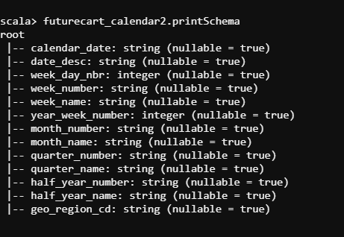

**futurecart_call_center_details.txt**

call_center_id call_center_vendor location country

spark.read.textFile("/user/edureka_918210/project_futurecart/batchdata/futurecart_call_center_details.txt").createOrReplaceTempView("futurecart_call_center_details");

val futurecart_call_center_details =

spark.sql(""" Select

split(value,'\t')[0] as call_center_id,

split(value,'\t')[1] as call_center_vendor,

split(value,'\t')[2] as location,

split(value,'\t')[3] as country

from futurecart_call_center_details """)

val futurecart_call_center_details2 = futurecart_call_center_details.selectExpr("cast(call_center_id as integer) call_center_id", "call_center_vendor", "location", "country")

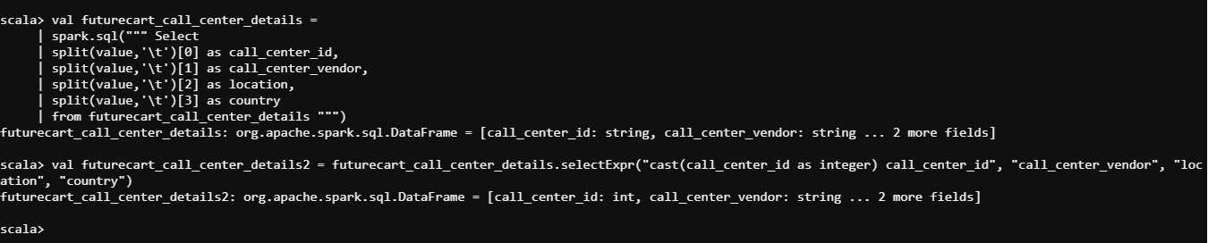

**futurecart_case_category_details.txt**

category_key sub_category_key category_description sub_category_description priority

CAT1 SCAT1 Subscription Renewal P1

CAT1 SCAT2 Subscription Termination P6

spark.read.textFile("/user/edureka_918210/project_futurecart/batchdata/futurecart_case_category_details.txt").createOrReplaceTempView("futurecart_case_category_details");

val futurecart_case_category_details =

spark.sql(""" Select

split(value,'\t')[0] as category_key,

split(value,'\t')[1] as sub_category_key,

split(value,'\t')[2] as category_description,

split(value,'\t')[3] as priority

from futurecart_case_category_details """)

val futurecart_case_category_details2 = futurecart_case_category_details.selectExpr("category_key", "sub_category_key", "category_description", "priority")

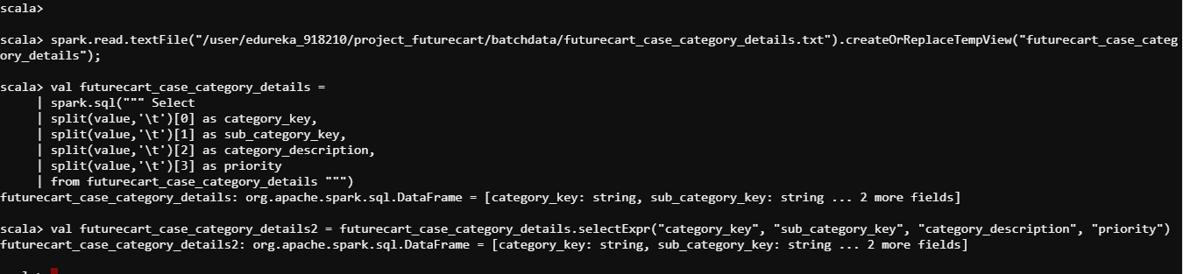

**futurecart_case_country_details.txt**

id name alpha_2 alpha_3

spark.read.textFile("/user/edureka_918210/project_futurecart/batchdata/futurecart_case_country_details.txt").createOrReplaceTempView("futurecart_case_country_details");

val futurecart_case_country_details =

spark.sql(""" Select

split(value,'\t')[0] as id,

split(value,'\t')[1] as name,

split(value,'\t')[2] as alpha_2,

split(value,'\t')[3] as alpha_3

from futurecart_case_country_details """)

val futurecart_case_country_details2 = futurecart_case_country_details.selectExpr("cast(id as integer) id", "name", "alpha_2", "alpha_3")

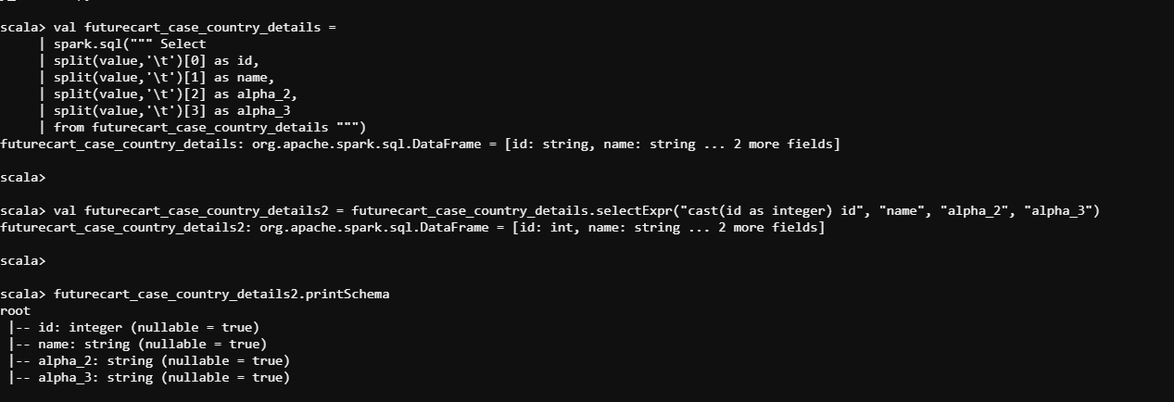

**futurecart_case_details.txt**

case_no create_timestamp last_modified_timestamp created_employee_key call_center_id status category sub_category communication_mode country_cd product_code

2024 2020-04-20 01:01:29 2020-04-20 01:01:29 274649 C-104 Open CAT1 SCAT1 Email PY 997719

spark.read.textFile("/user/edureka_918210/project_futurecart/batchdata/futurecart_case_details.txt").createOrReplaceTempView("futurecart_case_details");

val futurecart_case_details =

spark.sql(""" Select

split(value,'\t')[0] as case_no,

split(value,'\t')[1] as create_timestamp,

split(value,'\t')[2] as last_modified_timestamp,

split(value,'\t')[3] as created_employee_key,

split(value,'\t')[4] as call_center_id,

split(value,'\t')[5] as status,

split(value,'\t')[6] as category,

split(value,'\t')[7] as sub_category,

split(value,'\t')[8] as communication_mode,

split(value,'\t')[9] as country_cd,

split(value,'\t')[10] as product_code

from futurecart_case_details """)

val futurecart_case_details2 = futurecart_case_details.selectExpr("cast(case_no as integer) case_no", "create_timestamp", "last_modified_timestamp", "cast(created_employee_key as integer) created_employee_key","call_center_id","status","category","sub_category","communication_mode","country_cd","product_code")

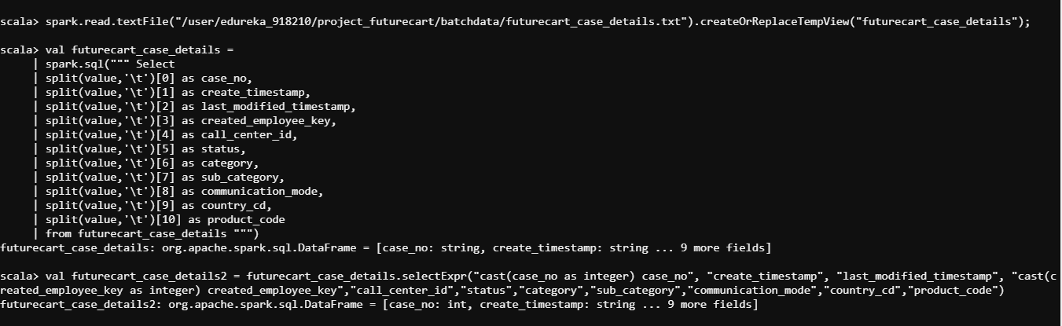

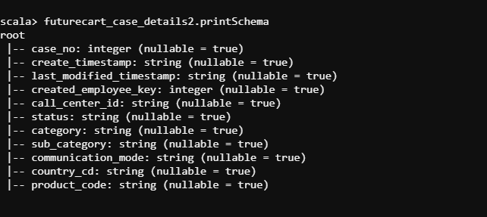

**futurecart_case_priority_details.txt**

priority_key priority severity SLA

P1 Highest Critical 1

spark.read.textFile("/user/edureka_918210/project_futurecart/batchdata/futurecart_case_priority_details.txt").createOrReplaceTempView("futurecart_case_priority_details");

val futurecart_case_priority_details =

spark.sql(""" Select

split(value,'\t')[0] as priority_key,

split(value,'\t')[1] as priority,

split(value,'\t')[2] as severity,

split(value,'\t')[3] as SLA

from futurecart_case_priority_details """)

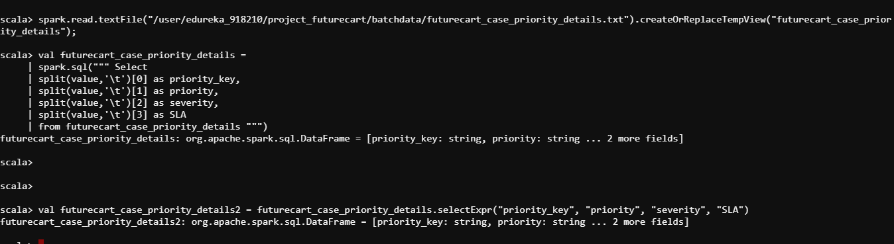

**futurecart_case_survey_details.txt**

/user/edureka_918210/project_futurecart/batchdata/futurecart_case_survey_details.txt

spark.read.textFile("/user/edureka_918210/project_futurecart/batchdata/futurecart_case_survey_details.txt").createOrReplaceTempView("futurecart_case_survey_details");

survey_id case_no survey_timestamp q1 q2 q3 q4 q5

S-1000 130114 2020-04-26 00:08:28 2 7 1 N 7

val futurecart_case_survey_details =

spark.sql(""" Select

split(value,'\t')[0] as survey_id,

split(value,'\t')[1] as case_no,

split(value,'\t')[2] as survey_timestamp,

split(value,'\t')[3] as q1,

split(value,'\t')[4] as q2,

split(value,'\t')[5] as q3,

split(value,'\t')[6] as q4,

split(value,'\t')[7] as q5

from futurecart_case_survey_details """)

val futurecart_case_survey_details2 = futurecart_case_survey_details.selectExpr("survey_id", "case_no", "survey_timestamp", "q1", "q2", "q3", "q4", "q5")

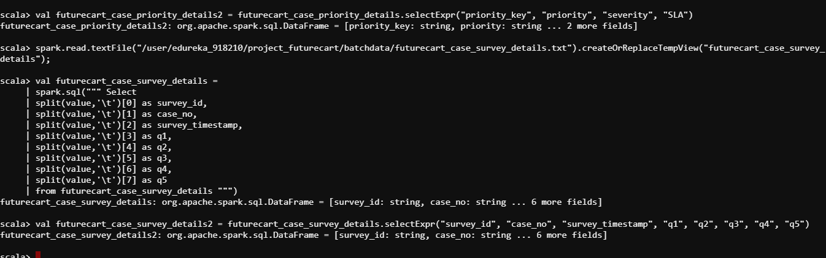

**futurecart_employee_details.txt**

/user/edureka_918210/project_futurecart/batchdata/futurecart_employee_details.txt

spark.read.textFile("/user/edureka_918210/project_futurecart/batchdata/futurecart_employee_details.txt").createOrReplaceTempView("futurecart_employee_details");

emp_key first_name last_name email gender ldap hire_date manager

10001 Georgi Facello Georgi.Facello01@testmail.com M 5941CF7D 2014-04-06

val futurecart_employee_details =

spark.sql(""" Select

split(value,'\t')[0] as emp_key,

split(value,'\t')[1] as first_name,

split(value,'\t')[2] as last_name,

split(value,'\t')[3] as email,

split(value,'\t')[4] as gender,

split(value,'\t')[5] as ldap,

split(value,'\t')[6] as hire_date,

split(value,'\t')[7] as manager

from futurecart_employee_details """)

val futurecart_employee_details2 = futurecart_employee_details.selectExpr("cast(emp_key as integer) emp_key", "first_name", "last_name", "email", "gender", "ldap", "hire_date", "manager")

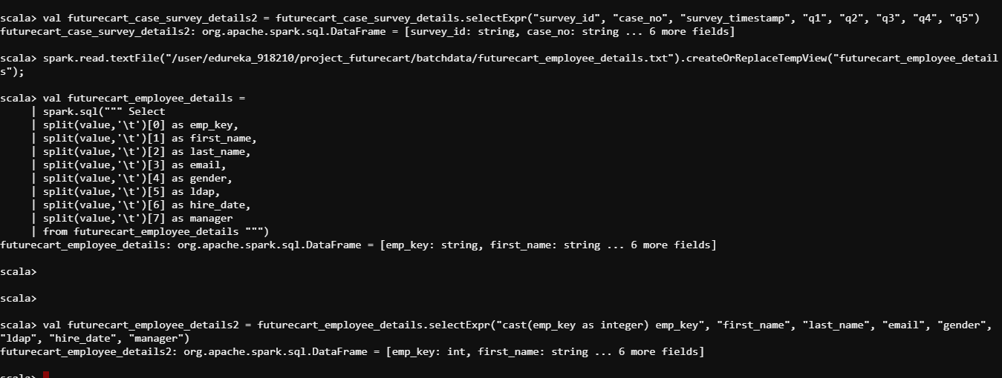

**futurecart_product_details.txt**

/user/edureka_918210/project_futurecart/batchdata/futurecart_product_details.txt

spark.read.textFile("/user/edureka_918210/project_futurecart/batchdata/futurecart_product_details.txt").createOrReplaceTempView("futurecart_product_details");

product_id department brand commodity_desc sub_commodity_desc

25671 GROCERY National FRZN ICE ICE - CRUSHED/CUBED

26081 MISC. TRANS. National NO COMMODITY DESCRIPTION NO SUBCOMMODITY DESCRIPTION

val futurecart_product_details =

spark.sql(""" Select

split(value,'\t')[0] as product_id,

split(value,'\t')[1] as department,

split(value,'\t')[2] as brand,

split(value,'\t')[3] as commodity_desc,

split(value,'\t')[4] as sub_commodity_desc

from futurecart_product_details """)

val futurecart_product_details2 = futurecart_product_details.selectExpr("cast(product_id as integer) product_id", "department", "brand", "commodity_desc", "sub_commodity_desc")

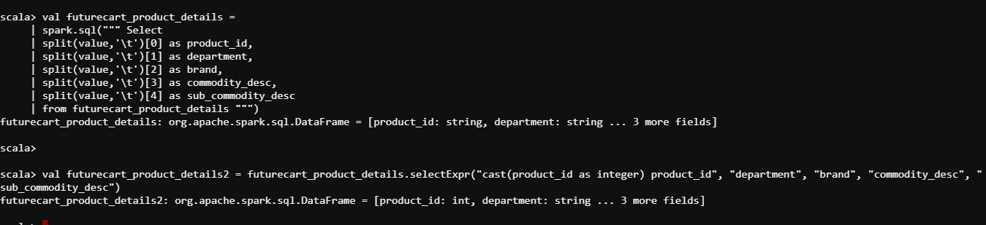

**futurecart_survey_question_details**

question_id question_desc response_type range negative_response_range neutral_response_range positive_response_range

Q1 How would you rate your overall experience with the customer support process? Scale 1-10 1-4 5-7 8-10

/user/edureka_918210/project_futurecart/batchdata/futurecart_survey_question_details.txt

spark.read.textFile("/user/edureka_918210/project_futurecart/batchdata/futurecart_survey_question_details.txt").createOrReplaceTempView("futurecart_survey_question_details");

val futurecart_survey_question_details =

spark.sql(""" Select

split(value,'\t')[0] as question_id,

split(value,'\t')[1] as question_desc,

split(value,'\t')[2] as response_type,

split(value,'\t')[3] as range,

split(value,'\t')[4] as negative_response_range,

split(value,'\t')[5] as neutral_response_range,

split(value,'\t')[6] as positive_response_range

from futurecart_survey_question_details """)

val futurecart_survey_question_details2 = futurecart_survey_question_details.selectExpr("question_id", "question_desc", "response_type", "range", "negative_response_range", "neutral_response_range", "positive_response_range")

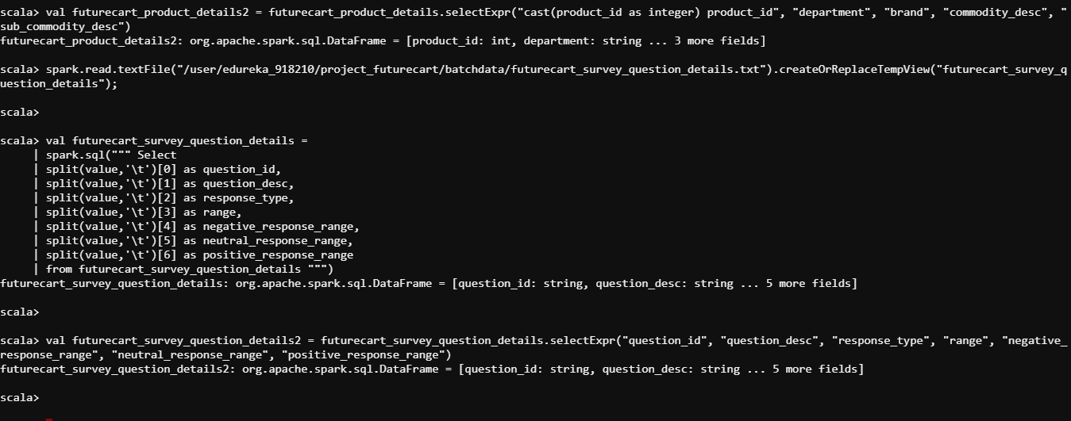

TO SAVE THE SPARK DATAFRAME INTO MYSQL : the mysql connector jar file is downloaded and connected.

spark2-shell --jars /mnt/home/edureka_918210/edureka_918210_retailcart/connector_jars/mysql-connector-java-5.1.48-bin.jar

futurecart_calendar2.write.format("jdbc").option("url","jdbc:mysql://dbserver.edu.cloudlab.com/labuser_database").option("dbtable","futurecart_calendar2").option("user","edu_labuser").option("password","edureka").option("driver","com.mysql.jdbc.Driver").mode("overwrite").save

futurecart_call_center_details2.write.format("jdbc").option("url","jdbc:mysql://dbserver.edu.cloudlab.com/labuser_database").option("dbtable","futurecart_call_center_details2").option("user","edu_labuser").option("password","edureka").option("driver","com.mysql.jdbc.Driver").mode("overwrite").save

futurecart_case_category_details2.write.format("jdbc").option("url","jdbc:mysql://dbserver.edu.cloudlab.com/labuser_database").option("dbtable","futurecart_case_category_details2").option("user","edu_labuser").option("password","edureka").option("driver","com.mysql.jdbc.Driver").mode("overwrite").save

futurecart_case_country_details2.write.format("jdbc").option("url","jdbc:mysql://dbserver.edu.cloudlab.com/labuser_database").option("dbtable","futurecart_case_country_details2").option("user","edu_labuser").option("password","edureka").option("driver","com.mysql.jdbc.Driver").mode("overwrite").save

futurecart_case_details2.write.format("jdbc").option("url","jdbc:mysql://dbserver.edu.cloudlab.com/labuser_database").option("dbtable","futurecart_case_details2").option("user","edu_labuser").option("password","edureka").option("driver","com.mysql.jdbc.Driver").mode("overwrite").save

futurecart_case_priority_details2.write.format("jdbc").option("url","jdbc:mysql://dbserver.edu.cloudlab.com/labuser_database").option("dbtable","futurecart_case_priority_details2").option("user","edu_labuser").option("password","edureka").option("driver","com.mysql.jdbc.Driver").mode("overwrite").save

futurecart_case_survey_details2.write.format("jdbc").option("url","jdbc:mysql://dbserver.edu.cloudlab.com/labuser_database").option("dbtable","futurecart_case_survey_details2").option("user","edu_labuser").option("password","edureka").option("driver","com.mysql.jdbc.Driver").mode("overwrite").save

futurecart_employee_details2.write.format("jdbc").option("url","jdbc:mysql://dbserver.edu.cloudlab.com/labuser_database").option("dbtable","futurecart_employee_details2").option("user","edu_labuser").option("password","edureka").option("driver","com.mysql.jdbc.Driver").mode("overwrite").save

futurecart_product_details2.write.format("jdbc").option("url","jdbc:mysql://dbserver.edu.cloudlab.com/labuser_database").option("dbtable","futurecart_product_details2").option("user","edu_labuser").option("password","edureka").option("driver","com.mysql.jdbc.Driver").mode("overwrite").save

futurecart_survey_question_details2.write.format("jdbc").option("url","jdbc:mysql://dbserver.edu.cloudlab.com/labuser_database").option("dbtable","futurecart_survey_question_details2").option("user","edu_labuser").option("password","edureka").option("driver","com.mysql.jdbc.Driver").mode("overwrite").save

mysql -u edu_labuser -h dbserver.edu.cloudlab.com -p

password - edureka

CREATE TABLE futurecart_calendar_details SELECT * FROM futurecart_calendar2;

CREATE TABLE futurecart_call_center_details SELECT * FROM futurecart_call_center_details2;

CREATE TABLE futurecart_case_category_details SELECT * FROM futurecart_case_category_details2;

CREATE TABLE futurecart_case_country_details SELECT * FROM futurecart_case_country_details2;

CREATE TABLE futurecart_case_details SELECT * FROM futurecart_case_details2;

CREATE TABLE futurecart_case_priority_details SELECT * FROM futurecart_case_priority_details2;

CREATE TABLE futurecart_case_survey_details SELECT * FROM futurecart_case_survey_details2;

CREATE TABLE futurecart_employee_details SELECT * FROM futurecart_employee_details2;

CREATE TABLE futurecart_product_details SELECT * FROM futurecart_product_details2;

CREATE TABLE futurecart_survey_question_details SELECT * FROM futurecart_survey_question_details2;

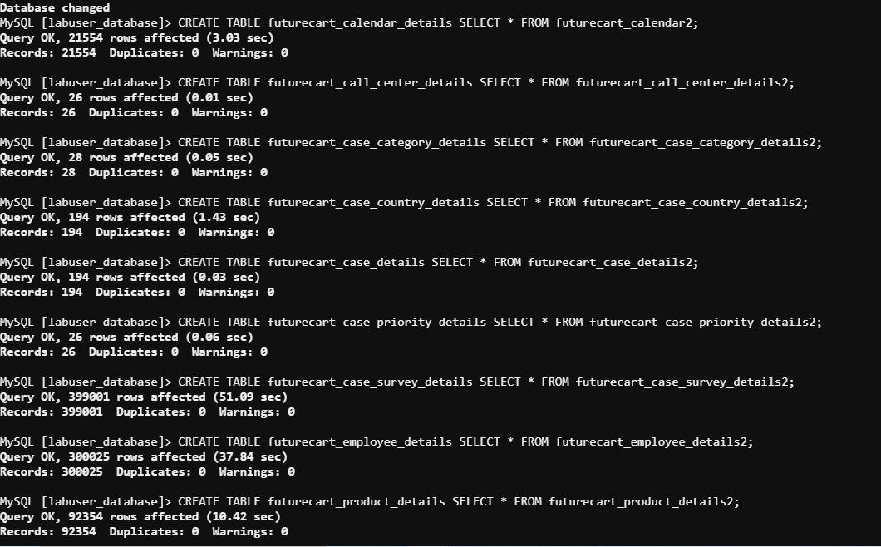

DB Details :edureka_918210_DB_Industry_projects_futurecart

**MYSQL TO HIVE**

MYSQL TO HIVE

================

sqoop import --connect jdbc:mysql://dbserver.edu.cloudlab.com/labuser_database --table futurecart_calendar_details -m 2 --hive-import --username edu_labuser --hive-database edureka_918210_DB_Industry_projects_futurecart --split-by calendar_date --password edureka

sqoop import --connect jdbc:mysql://dbserver.edu.cloudlab.com/labuser_database --table futurecart_call_center_details -m 2 --hive-import --username edu_labuser --hive-database edureka_918210_DB_Industry_projects_futurecart --split-by call_center_id --password edureka

sqoop import --connect jdbc:mysql://dbserver.edu.cloudlab.com/labuser_database --table futurecart_case_category_details -m 2 --hive-import --username edu_labuser --hive-database edureka_918210_DB_Industry_projects_futurecart --split-by sub_category_key --password edureka

sqoop import --connect jdbc:mysql://dbserver.edu.cloudlab.com/labuser_database --table futurecart_case_country_details -m 2 --hive-import --username edu_labuser --hive-database edureka_918210_DB_Industry_projects_futurecart --split-by id --password edureka

sqoop import --connect jdbc:mysql://dbserver.edu.cloudlab.com/labuser_database --table futurecart_case_details -m 2 --hive-import --username edu_labuser --hive-database edureka_918210_DB_Industry_projects_futurecart --split-by case_no --password edureka

sqoop import --connect jdbc:mysql://dbserver.edu.cloudlab.com/labuser_database --table futurecart_case_priority_details -m 2 --hive-import --username edu_labuser --hive-database edureka_918210_DB_Industry_projects_futurecart --split-by priority_key --password edureka

sqoop import --connect jdbc:mysql://dbserver.edu.cloudlab.com/labuser_database --table futurecart_case_survey_details -m 2 --hive-import --username edu_labuser --hive-database edureka_918210_DB_Industry_projects_futurecart --split-by survey_id --password edureka

sqoop import --connect jdbc:mysql://dbserver.edu.cloudlab.com/labuser_database --table futurecart_employee_details -m 2 --hive-import --username edu_labuser --hive-database edureka_918210_DB_Industry_projects_futurecart --split-by emp_key --password edureka

sqoop import --connect jdbc:mysql://dbserver.edu.cloudlab.com/labuser_database --table futurecart_product_details -m 2 --hive-import --username edu_labuser --hive-database edureka_918210_DB_Industry_projects_futurecart --split-by product_id --password edureka

sqoop import --connect jdbc:mysql://dbserver.edu.cloudlab.com/labuser_database --table futurecart_survey_question_details -m 2 --hive-import --username edu_labuser --hive-database edureka_918210_DB_Industry_projects_futurecart --split-by question_id --password edureka

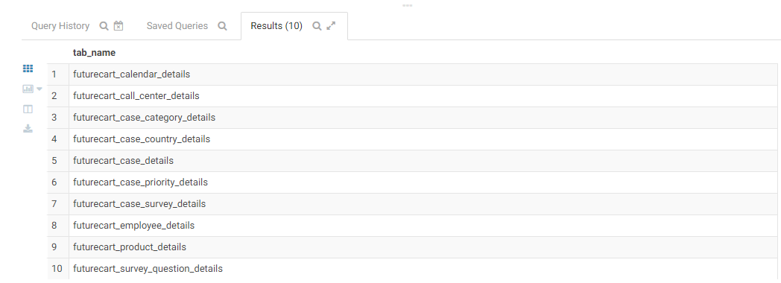

SPARK TO Hive

=================

val spark = SparkSession.builder().appName("Industry_Grade_Project-spark").master("local[*]").enableHiveSupport().getOrCreate();

spark.sql("Show tables in edureka_918210_DB_Industry_projects_futurecart").show(false)

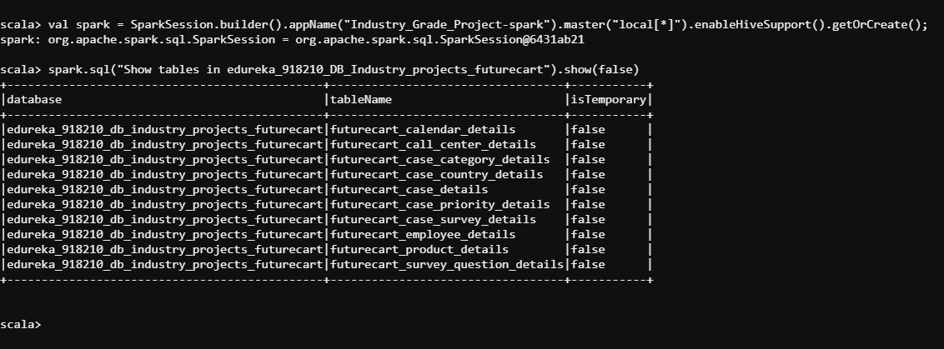

REAL TIME DATA

hdfs dfs -get /bigdatapgp/common_folder/project_futurecart/realtimedata

python2 realtimedata/realtime_simulator.py --outputLocation /mnt/home/edureka_918210/project_retailcart/realtimedata

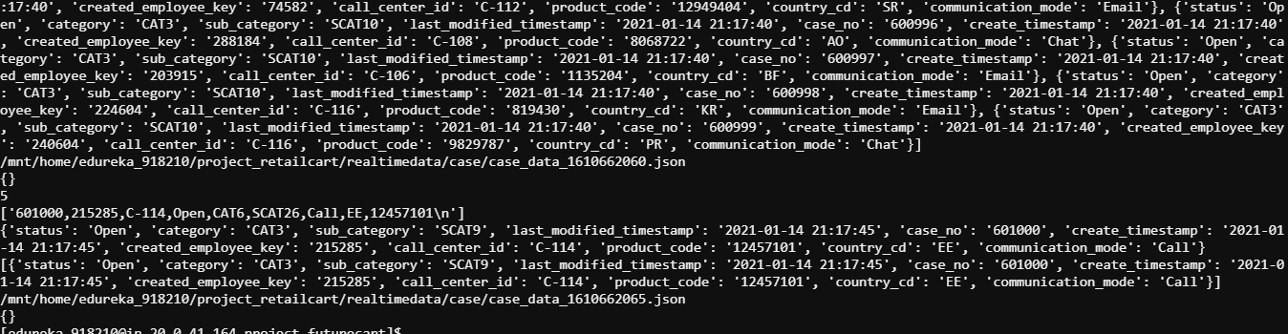

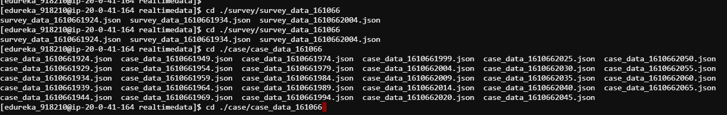

python2 realtimedata/realtime_simulator.py --outputLocation /mnt/home/edureka_918210/project_retailcart/realtimedata

**LOCATION :**

/mnt/home/edureka_918210/project_futurecart/realtimedata/case - File Location

spark2-shell --jars /mnt/home/edureka_918210/edureka_918210_retailcart/connector_jars/mysql-connector-java-5.1.48-bin.jar

val spark = SparkSession.builder().appName("Industry_Grade_Project-spark").master("local[*]").enableHiveSupport().getOrCreate();

val RealTimeDFCase = spark.read.json("/user/edureka_918210/project_futurecart/realtimedata/case")

RealTimeDFCase: org.apache.spark.sql.DataFrame = [call_center_id: string, case_no: string ... 9 more fields]

scala>

scala> RealTimeDFCase.printSchema

scala> RealTimeDFCase.show(4)

RealTimeDFCase.write.format("jdbc").option("url","jdbc:mysql://dbserver.edu.cloudlab.com/labuser_database").option("dbtable","RealTimeDFCase").option("user","edu_labuser").option("password","edureka").option("driver","com.mysql.jdbc.Driver").mode("overwrite").save

mysql -u edu_labuser -h dbserver.edu.cloudlab.com -p

MySQL [labuser_database]> describe RealTimeDFCase;

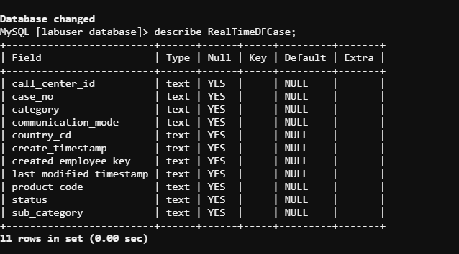

val RealTimeDFsurvey = spark.read.json("/user/edureka_918210/project_futurecart/realtimedata/survey")

RealTimeDFsurvey.write.format("jdbc").option("url","jdbc:mysql://dbserver.edu.cloudlab.com/labuser_database").option("dbtable","RealTimeDFsurvey").option("user","edu_labuser").option("password","edureka").option("driver","com.mysql.jdbc.Driver").mode("overwrite").save

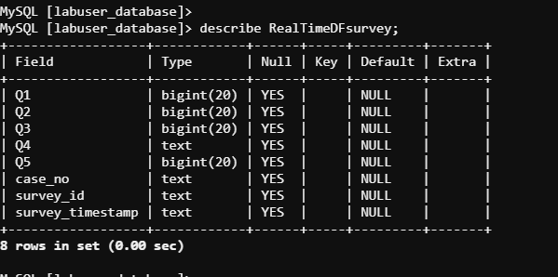

**hive tables from mysql**

sqoop import --connect jdbc:mysql://dbserver.edu.cloudlab.com/labuser_database \

--username edu_labuser \

--P \

--split-by survey_id \

--columns Q1,Q2,Q3,Q4,Q5,case_no,survey_id,survey_timestamp \

--table RealTimeDFsurvey \

--target-dir /user/edureka_918210/project_futurecart/RealTimeDFsurvey \

--fields-terminated-by "," \

--hive-import \

--create-hive-table \

--hive-table edureka_918210_DB_Industry_projects_futurecart.RealTimeDFsurvey

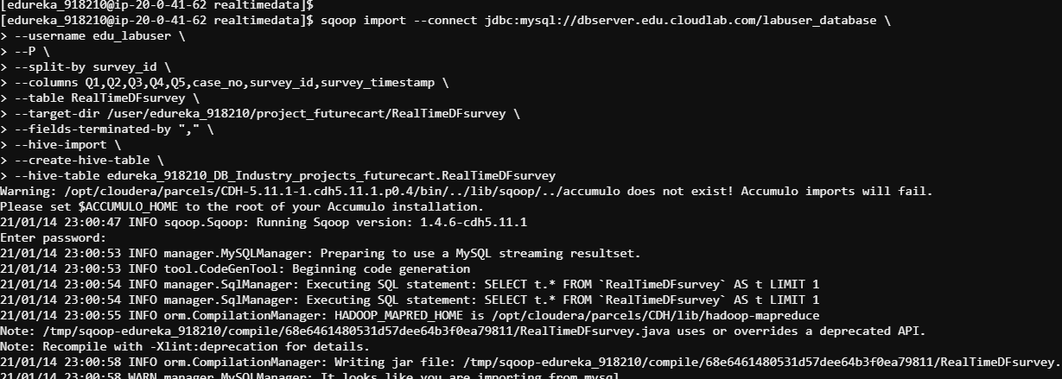

sqoop import --connect jdbc:mysql://dbserver.edu.cloudlab.com/labuser_database \

--username edu_labuser \

--P \

--split-by call_center_id \

--columns call_center_id,case_no,category,communication_mode,country_cd,create_timestamp,created_employee_key,last_modified_timestamp,product_code,status,sub_category \

--table RealTimeDFCase \

--target-dir /user/edureka_918210/project_futurecart/RealTimeDFCase \

--fields-terminated-by "," \

--hive-import \

--create-hive-table \

--hive-table edureka_918210_DB_Industry_projects_futurecart.RealTimeDFCase

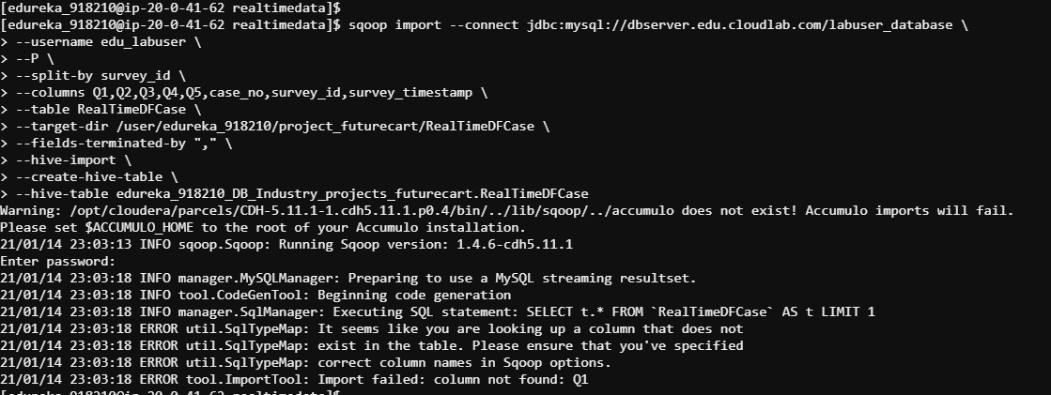

/user/edureka_918210/project_futurecart/RealTimeDFsurvey -- HDFS location

/user/edureka_918210/project_futurecart/RealTimeDFCase -- HDFS location

MYSQL TO HBase

sqoop import --connect jdbc:mysql://dbserver.edu.cloudlab.com/labuser_database --table RealTimeDFCase --hbase-table ' RealTimeDFCase' --column-family cf2 --username edu_labuser --hbase-create-table --columns call_center_id,case_no,category,communication_mode,country_cd,create_timestamp,created_employee_key,last_modified_timestamp,product_code,status,sub_category --hbase-row-key call_center_id -m 1 --password edureka

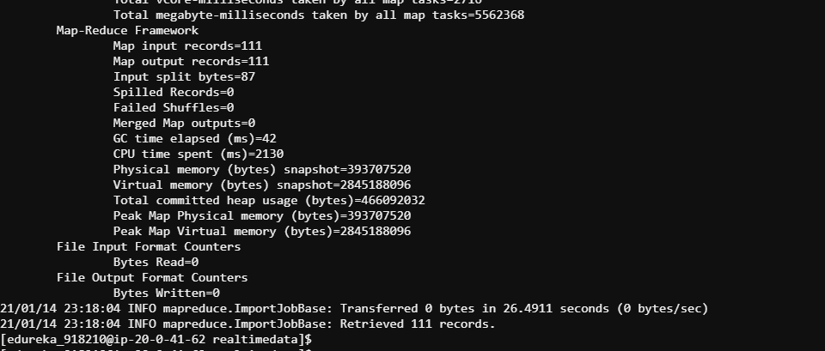

sqoop import --connect jdbc:mysql://dbserver.edu.cloudlab.com/labuser_database --table RealTimeDFsurvey --hbase-table 'RealTimeDFsurvey' --column-family cf2 --username edu_labuser --hbase-create-table --columns Q1,Q2,Q3,Q4,Q5,case_no,survey_id,survey_timestamp --hbase-row-key survey_id -m 1 --password edureka

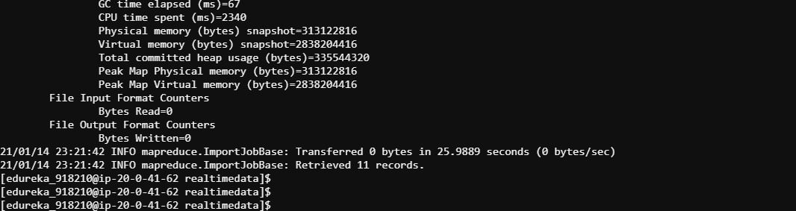

**Tables Descriptions**

**describe edureka_918210_DB_Industry_projects_futurecart.futurecart_calendar_details**

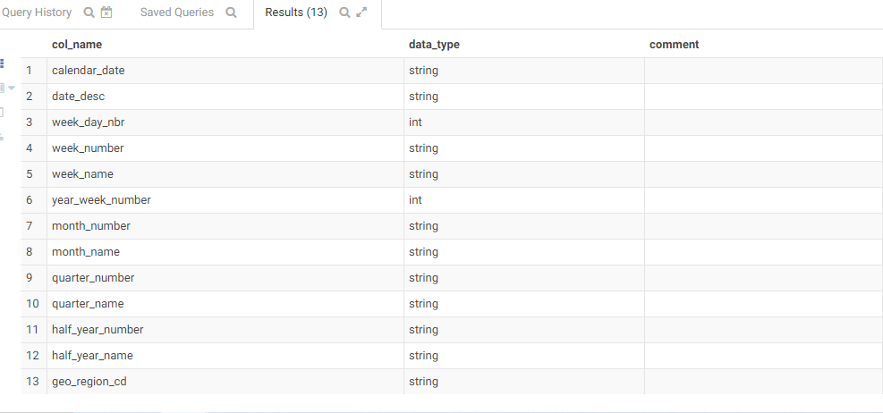

**describe edureka_918210_DB_Industry_projects_futurecart.futurecart_call_center_details**

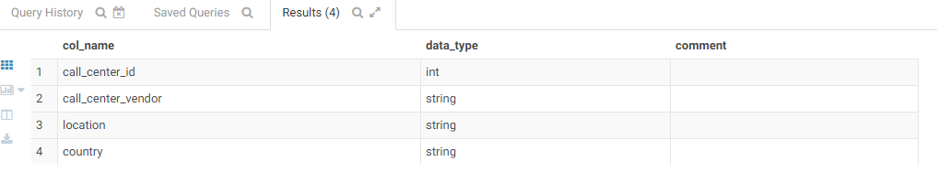

**describe edureka_918210_DB_Industry_projects_futurecart. futurecart_case_category_details**

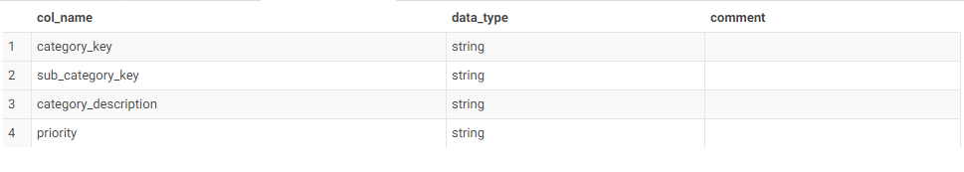

**describe edureka_918210_DB_Industry_projects_futurecart.futurecart_case_country_details**

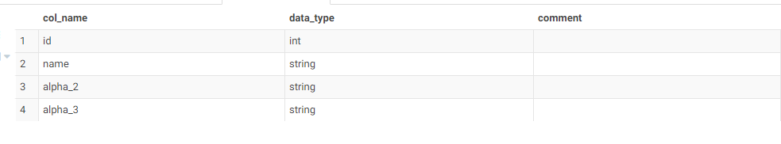

**describe edureka_918210_DB_Industry_projects_futurecart.futurecart_case_details**

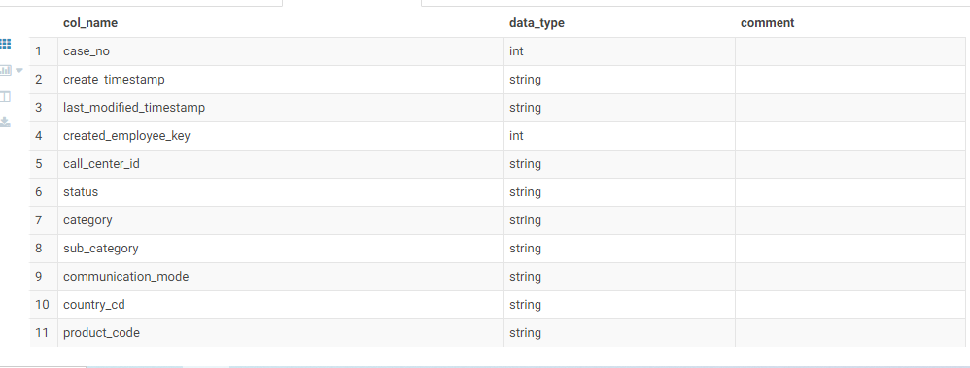

**describe edureka_918210_DB_Industry_projects_futurecart.futurecart_case_priority_details**

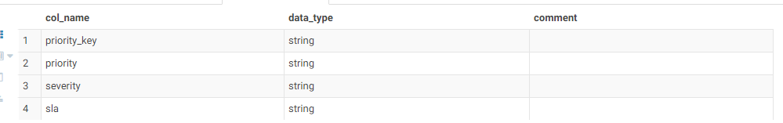

**describe edureka_918210_DB_Industry_projects_futurecart.futurecart_case_survey_details**

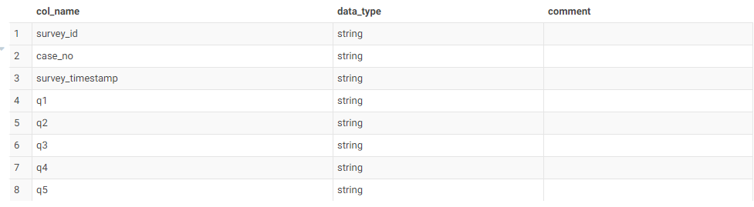

**describe edureka_918210_DB_Industry_projects_futurecart.futurecart_employee_details**

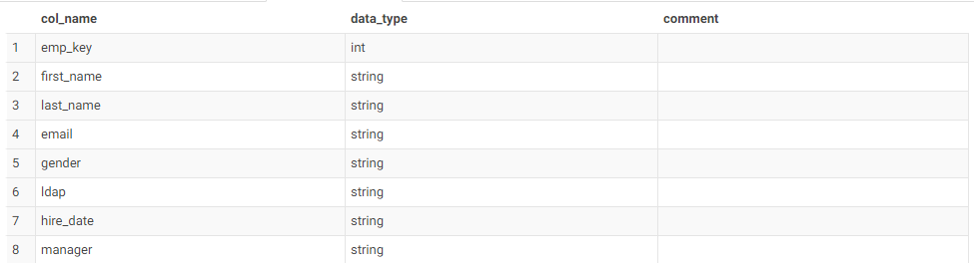

**describe edureka_918210_DB_Industry_projects_futurecart.futurecart_product_details**

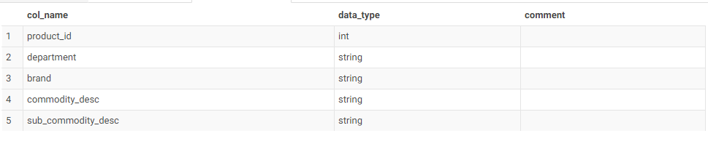

**describe edureka_918210_DB_Industry_projects_futurecart.futurecart_survey_question_details**

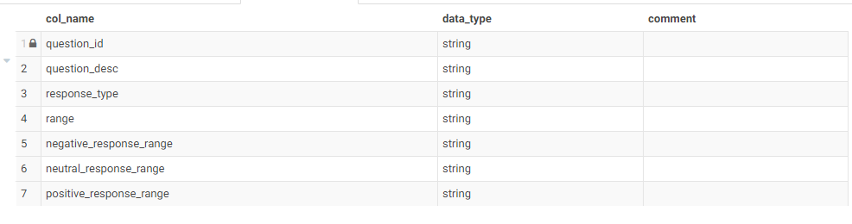

**describe edureka_918210_DB_Industry_projects_futurecart.realtimedfcase**

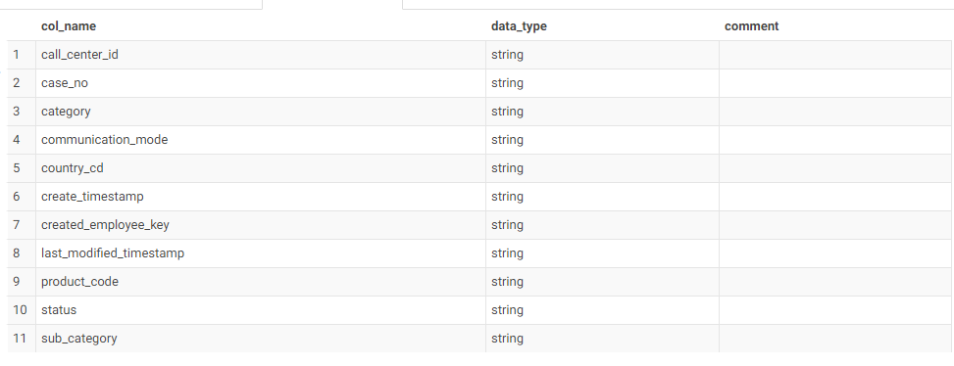

**describe edureka_918210_DB_Industry_projects_futurecart.realtimedfsurvey**

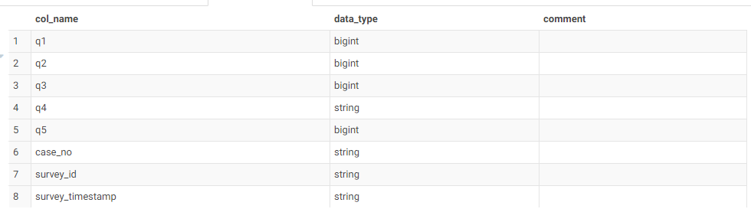

**PROJECT KPIs**

KPIs (Both on real-time data and batch-processed data)

• Total numbers of cases

• Total open cases in the last 1 hour

• Total closed cases in the last 1 hour

• Total priority cases 4

• Total positive/negative responses in the last 1 hour

• Total number of surveys in the last 1 hour

• Total open cases in a day/week/month

• Total closed cases in a day/week/month

• Total positive/negative responses in a day/week/month

• Total number of surveys in a day/week/month

Real-time KPIs

• Total numbers of cases that are open and closed out of the number of cases received

• Total number of cases received based on priority and severity

val futurecart_calendar_details = spark.sql("select * from edureka_918210_DB_Industry_projects_futurecart.futurecart_calendar_details")

val futurecart_call_center_details = spark.sql("select * from edureka_918210_DB_Industry_projects_futurecart.futurecart_call_center_details")

val futurecart_case_category_details = spark.sql("select * from edureka_918210_DB_Industry_projects_futurecart.futurecart_case_category_details")

val futurecart_case_country_details = spark.sql("select * from edureka_918210_DB_Industry_projects_futurecart.futurecart_case_country_details")

val futurecart_case_details = spark.sql("select * from edureka_918210_DB_Industry_projects_futurecart.futurecart_case_details")

val futurecart_case_priority_details = spark.sql("select * from edureka_918210_DB_Industry_projects_futurecart.futurecart_case_priority_details")

val futurecart_case_survey_details = spark.sql("select * from edureka_918210_DB_Industry_projects_futurecart.futurecart_case_survey_details")

val futurecart_employee_details = spark.sql("select * from edureka_918210_DB_Industry_projects_futurecart.futurecart_employee_details")

val futurecart_product_details = spark.sql("select * from edureka_918210_DB_Industry_projects_futurecart.futurecart_product_details")

val futurecart_survey_question_details = spark.sql("select * from edureka_918210_DB_Industry_projects_futurecart.futurecart_survey_question_details")

val RealTimeDFCase = spark.sql("select * from edureka_918210_DB_Industry_projects_futurecart.RealTimeDFCase")

val RealTimeDFsurvey = spark.sql("select * from edureka_918210_DB_Industry_projects_futurecart.RealTimeDFsurvey")

**Total numbers of cases**

select count(*) from edureka_918210_DB_Industry_projects_futurecart.futurecart_case_country_details

193

**Total open cases in the last 1 hour**

val RealTimeDFCase2 = RealTimeDFCase.withColumn("date", to_date($"last_modified_timestamp")).withColumn("hour", hour(col("last_modified_timestamp"))).withColumn("minute", minute(col("last_modified_timestamp"))).withColumn("second", second(col("last_modified_timestamp")))

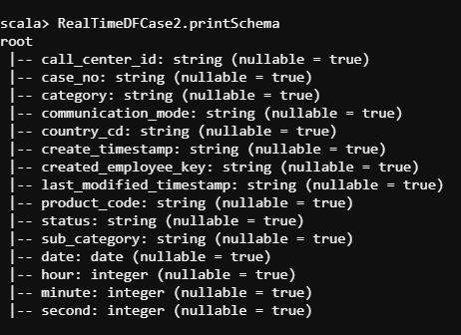

val RealTimeDFCase3 = RealTimeDFCase2.orderBy(desc("hour")).select("call_center_id","case_no","country_cd","status","date","hour","minute","second")

RealTimeDFCase3.filter(RealTimeDFCase3("status")==="Open").show(10)

scala> RealTimeDFCase3.filter((RealTimeDFCase3("status")==="Open") && (RealTimeDFCase3("hour") === 21) && (RealTimeDFCase3("minute").between(0,59))).count()

res1: Long = 100

RealTimeDFCase3.filter((RealTimeDFCase3("status")==="Open") && (RealTimeDFCase3("hour") === 21) && (RealTimeDFCase3("minute").between(0,59))).show(10)

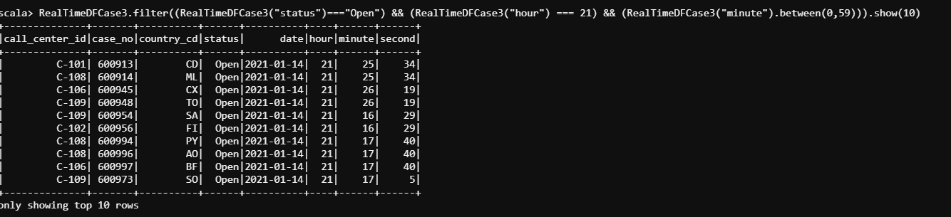

**Total closed cases in the last 1 hour**

RealTimeDFCase3.filter((RealTimeDFCase3("status")==="Closed") && (RealTimeDFCase3("hour") === 21) && (RealTimeDFCase3("minute").between(0,59))).show(10)

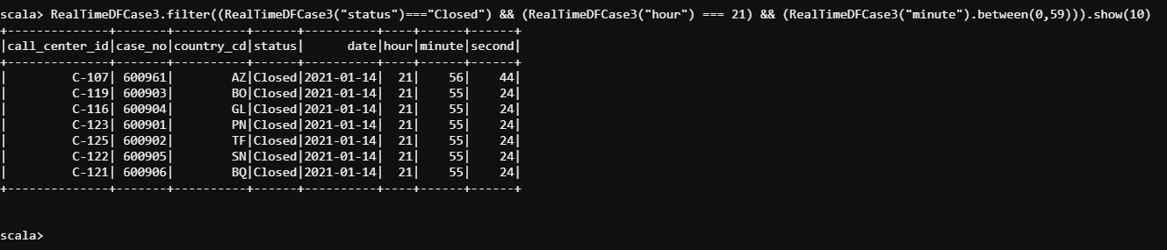

scala> RealTimeDFCase3.filter((RealTimeDFCase3("status")==="Closed") && (RealTimeDFCase3("hour") === 21) && (RealTimeDFCase3("minute").between(0,59))).count()

res3: Long = 7

scala>

**Total priority cases 4**

scala> futurecart_case_priority_details.filter((futurecart_case_priority_details("priority_key")==="P4")).count()

res6: Long = 1 scala>

**Total positive/negative responses in the last 1 hour**

val RealTimeDFsurvey2 = RealTimeDFsurvey.withColumn("Positive_NegativeQ1", when(col("q1").isin("1", "4"), "Negative").otherwise(when(col("q1").isin("5", "7"), "Positive").otherwise("Neutral")))

val RealTimeDFsurvey3 = RealTimeDFsurvey2.withColumn("Positive_NegativeQ2", when(col("q2").isin("1", "5"), "Negative").otherwise(when(col("q2").isin("6", "8"), "Positive").otherwise("Neutral")))

val RealTimeDFsurvey4 = RealTimeDFsurvey3.withColumn("Positive_NegativeQ3", when(col("q3").isin("1", "4"), "Negative").otherwise(when(col("q3").isin("5", "7"), "Positive").otherwise("Neutral")))

val RealTimeDFsurvey5 = RealTimeDFsurvey4.withColumn("Positive_NegativeQ4", when(col("q4").isin("1", "4"), "NA").otherwise(when(col("q4").isin("5", "7"), "NA").otherwise("NA")))

val RealTimeDFsurvey6 = RealTimeDFsurvey4.withColumn("Positive_NegativeQ5", when(col("q5").isin("1", "5"), "Negative").otherwise(when(col("q5").isin("6", "8"), "Positive").otherwise("NA")))

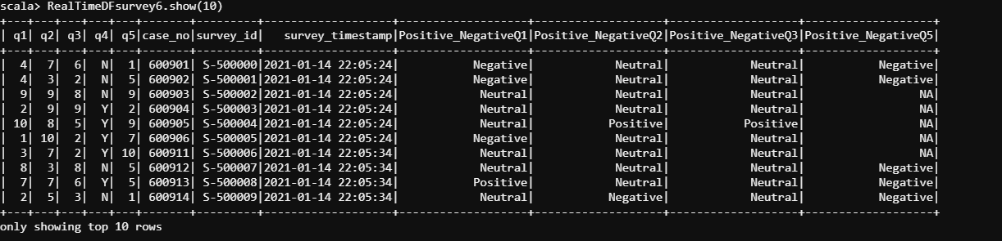

**Total number of surveys in the last 1 hour**

scala> RealTimeDFsurvey.count()res18: Long = 11 scala>

**Total opened cases in a day/week/month**

**=====================================**

scala> futurecart_case_details.printSchema

root

|-- case_no: integer (nullable = true)

|-- create_timestamp: string (nullable = true)

|-- last_modified_timestamp: string (nullable = true)

|-- created_employee_key: integer (nullable = true)

|-- call_center_id: string (nullable = true)

|-- status: string (nullable = true)

|-- category: string (nullable = true)

|-- sub_category: string (nullable = true)

|-- communication_mode: string (nullable = true)

|-- country_cd: string (nullable = true)

|-- product_code: string (nullable = true)

scala> futurecart_case_details.count()

res4: Long = 808265

val futurecart_case_details2 = futurecart_case_details.withColumn("date", to_date($"last_modified_timestamp")).withColumn("month", month(col("last_modified_timestamp"))).withColumn("day", day(col("last_modified_timestamp")))

scala> futurecart_case_details2.printSchema

root

|-- case_no: integer (nullable = true)

|-- create_timestamp: string (nullable = true)

|-- last_modified_timestamp: string (nullable = true)

|-- created_employee_key: integer (nullable = true)

|-- call_center_id: string (nullable = true)

|-- status: string (nullable = true)

|-- category: string (nullable = true)

|-- sub_category: string (nullable = true)

|-- communication_mode: string (nullable = true)

|-- country_cd: string (nullable = true)

|-- product_code: string (nullable = true)

|-- date: date (nullable = true)

|-- month: integer (nullable = true)

|-- day: integer (nullable = true)

futurecart_case_details2.filter((futurecart_case_details2("status")==="Open").groupBy("month")

futurecart_case_details2.filter((futurecart_case_details2("status")==="Open").groupBy("day")

**Total closed cases in a day/week/month**

**=======================================**

scala> futurecart_case_details2.printSchema

root

|-- case_no: integer (nullable = true)

|-- create_timestamp: string (nullable = true)

|-- last_modified_timestamp: string (nullable = true)

|-- created_employee_key: integer (nullable = true)

|-- call_center_id: string (nullable = true)

|-- status: string (nullable = true)

|-- category: string (nullable = true)

|-- sub_category: string (nullable = true)

|-- communication_mode: string (nullable = true)

|-- country_cd: string (nullable = true)

|-- product_code: string (nullable = true)

|-- date: date (nullable = true)

|-- month: integer (nullable = true)

import org.apache.spark.sql.functions._

futurecart_case_details2.filter((futurecart_case_details2("status")==="Closed").groupBy("month")

futurecart_case_details2.filter((futurecart_case_details2("status")==="Closed").groupBy("day")

**Total positive/negative responses in a day/week/month**

RealTimeDFsurvey6.filter(("Positive_NegativeQ1")==="Positive").count().groupBy("month")

RealTimeDFsurvey6.filter(("Positive_NegativeQ1")==="Negative").count().groupBy("month")

RealTimeDFsurvey6.filter(("Positive_NegativeQ1")==="Positive").count().groupBy("day")

RealTimeDFsurvey6.filter(("Positive_NegativeQ1")==="Negative").count().groupBy("day")

RealTimeDFsurvey6.filter(("Positive_NegativeQ2")==="Positive").count().groupBy("month")

RealTimeDFsurvey6.filter(("Positive_NegativeQ2")==="Negative").count().groupBy("month")

RealTimeDFsurvey6.filter(("Positive_NegativeQ2")==="Positive").count().groupBy("day")

RealTimeDFsurvey6.filter(("Positive_NegativeQ2")==="Negative").count().groupBy("day")

RealTimeDFsurvey6.filter(("Positive_NegativeQ3")==="Positive").count().groupBy("month")

RealTimeDFsurvey6.filter(("Positive_NegativeQ3")==="Negative").count().groupBy("month")

RealTimeDFsurvey6.filter(("Positive_NegativeQ3")==="Positive").count().groupBy("day")

RealTimeDFsurvey6.filter(("Positive_NegativeQ3")==="Negative").count().groupBy("day")

**Total number of surveys in a day/week/month**

**============================================**

scala> futurecart_case_details2.printSchema

root

|-- case_no: integer (nullable = true)

|-- create_timestamp: string (nullable = true)

|-- last_modified_timestamp: string (nullable = true)

|-- created_employee_key: integer (nullable = true)

|-- call_center_id: string (nullable = true)

|-- status: string (nullable = true)

|-- category: string (nullable = true)

|-- sub_category: string (nullable = true)

|-- communication_mode: string (nullable = true)

|-- country_cd: string (nullable = true)

|-- product_code: string (nullable = true)

|-- date: date (nullable = true)

|-- month: integer (nullable = true)

futurecart_case_details2.filter((futurecart_case_details2("case_no").count()).groupBy("month")

futurecart_case_details2.filter((futurecart_case_details2("case_no").count()).groupBy("day")